Lesson 02 Demo 07

Creating Resource Lock

Objective: To create a resource lock to have more control over access
Tools Required: None

Prerequisites: Resource group

Steps to be followed:
- Configure locks on Azure resources
Step 1: Configure locks on Azure resources

- Go to Azure Portal and select the Resource groups

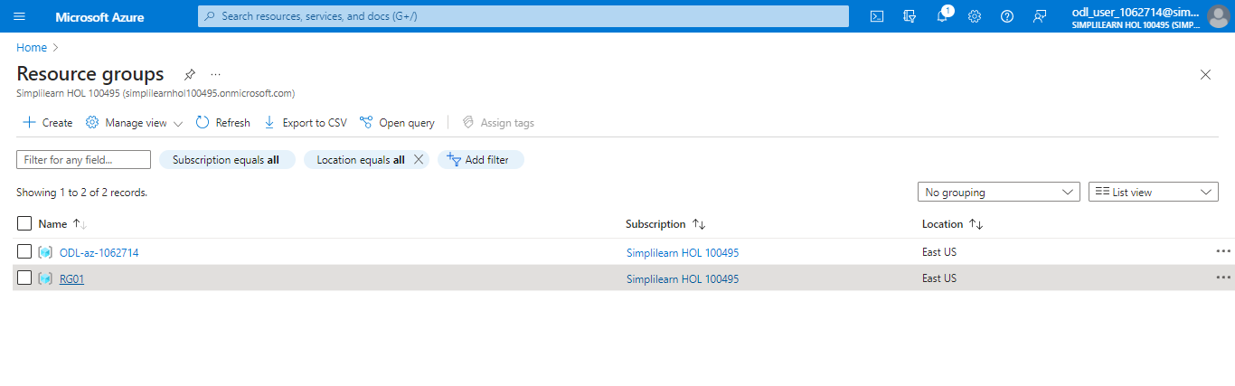

- Navigate to the resource group you've created, and within its settings, choose Locks
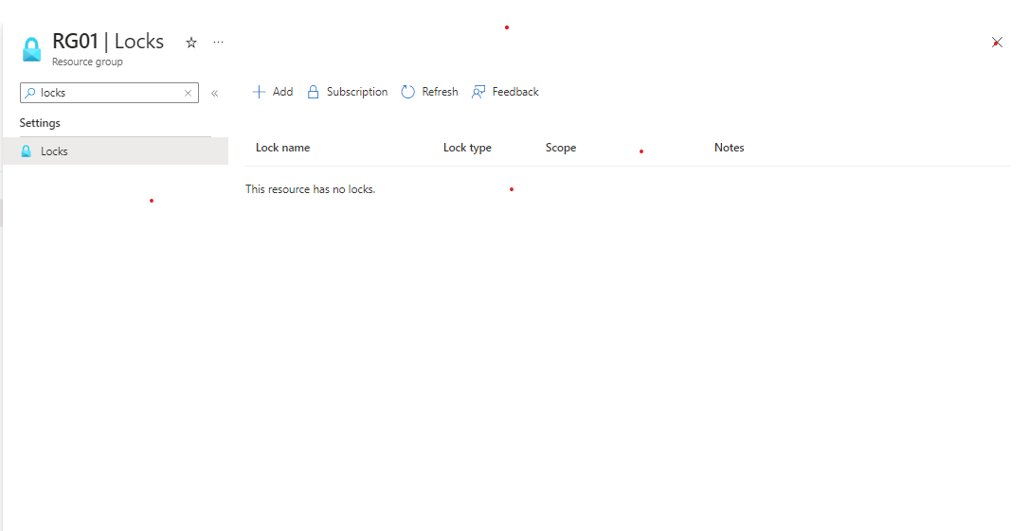

- To add a lock, click on Add, enter a Name, choose Lock type, and click on OK

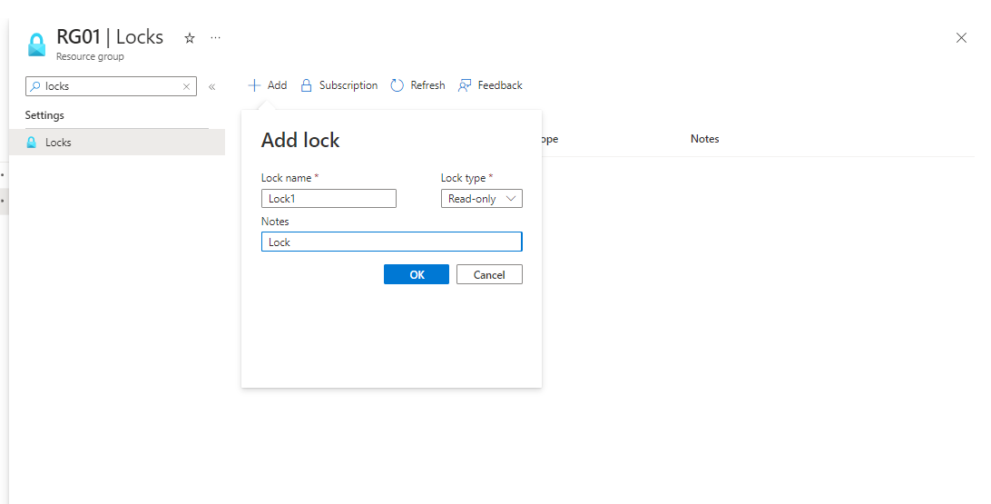

The output appears as follows:

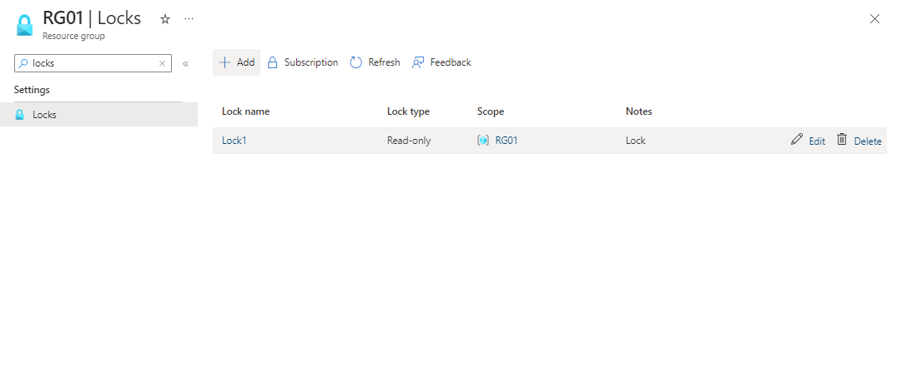

You have now successfully created the Azure locks to have more control over access and deletion of Azure Resources.

